

**MDW Designer RCP Install Guide**

Note: These instructions are for installing Designer in standalone mode. To install the MDW Plugin for Eclipse, refer to this guide:

[**http://cshare.ad.qintra.com/sites/MDW/Developer Resources/Installing and Upgrading the MDW Plugin for Eclipse.html**](http://cshare.ad.qintra.com/sites/MDW/Developer%20Resources/Installing%20and%20Upgrading%20the%20MDW%20Plugin%20for%20Eclipse.html)

**Installation Steps:**

**1: Download the Installation Zip File**

Copy the latest distribution zip file from the following shared location to your hard drive.

Note: avoid extracting the contents onto the shared folder (instead copy the zip file locally first before exploding).

**\\eldnp1515dm4.ad.qintra.com\union_station\IT\MDW\RCP**

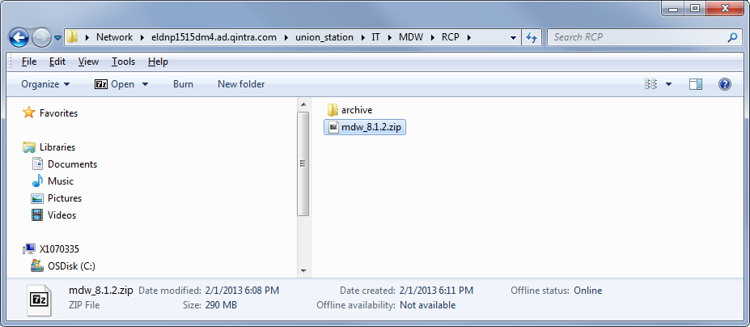

**2: Extract the Zip File Contents**

* Right-click on the downloaded zip file in Windows Explorer and select Extract All…

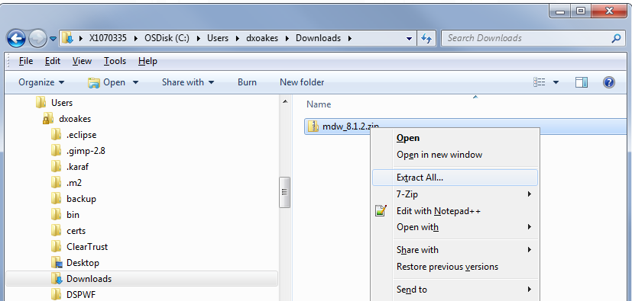

* Extract into C:\Program Files or into the desired folder (the archive already contains an MDW subfolder):

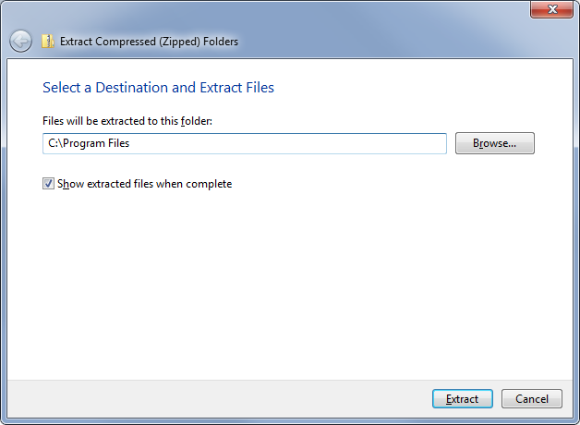

**3: Run MDW Designer**

Double click on the file mdw.exe (or set up a shortcut pointing to C:\Program Files\mdw\mdw.exe.

Log in using your LDAP user name and password:

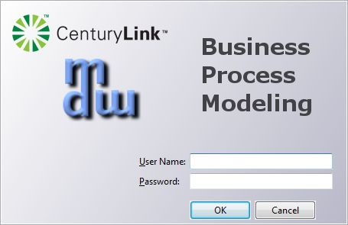

**4: Get Started with MDW Designer**

Refer to the MDW Designer User Guide:

[**http://cshare.ad.qintra.com/sites/MDW/User Documentation/MDW Designer User Guide.doc**](http://cshare.ad.qintra.com/sites/MDW/User%20Documentation/MDW%20Designer%20User%20Guide.doc)